# Creating a Folder Aciton to Automatically Sort Screenshots into Dated Folders

# Contents

1. Creating the automation with Automator
2. Changing the default name of the screencapture file
3. Changing the default save directory for screenshots
4. Copy the automation workflow to /Library/Scripts/Folder Actions Scripts/
5. Make sure the folder actions are set up

# Creating the automation with Automator

Open the Automator app and set up the following automation. The script is an AppleScript variable.

set dateFolder to do shell script "echo $(date '+%Y-%m-%d')"

tell application "Finder"

set SSFolder to (path to desktop folder as text) & "Screenshots:"

if not (exists (SSFolder & dateFolder)) then

make new folder at SSFolder with properties {name:dateFolder}

end if

end tell

(((path to desktop folder) as text) & "Screenshots" & ":" & dateFolder) as alias

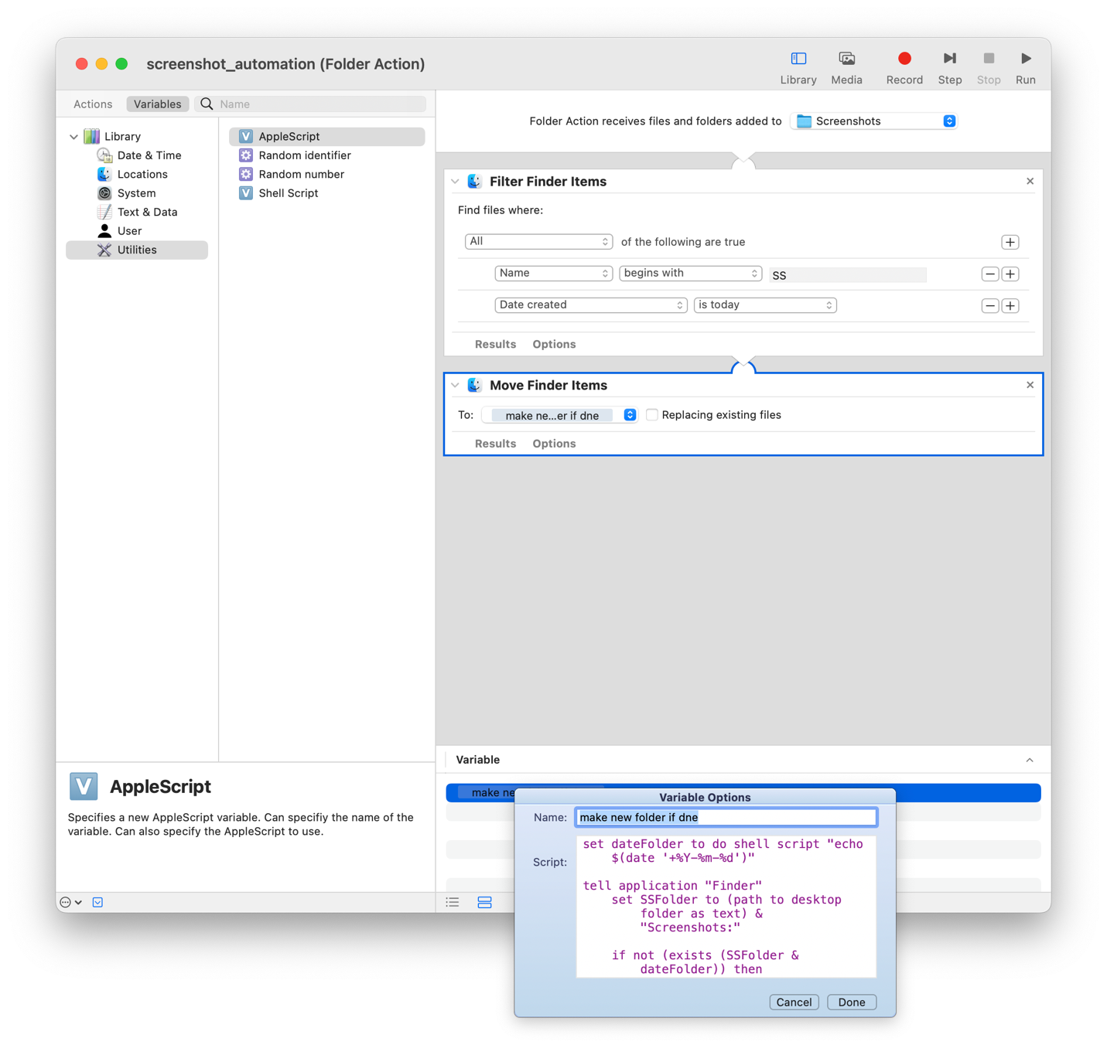

# Changing the default name of the screencapture file

In a terminal type the following

defaults write com.apple.screencapture name "SS"

# Changing the default save directory for screenshots

Open the screenshots app by typing screenshots and then choose another location to save to

# Copy the automation workflow to /Library/Scripts/Folder Actions Scripts/

Scripts need to be in this location to be selectable in folder actions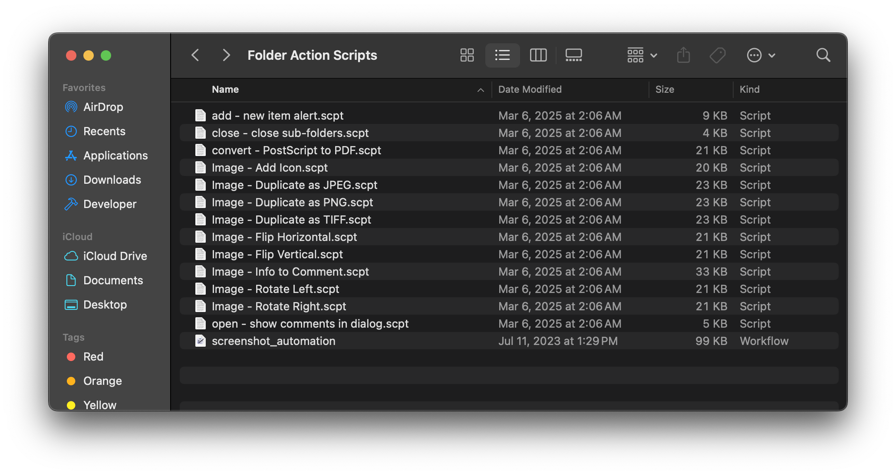

# Make sure the folder actions are set up

Right click the destination folder and select folder actions setup in the services menu

